Financial Risk ANalytics
Business Report

Guided Project
By
Rajesh Mambulli

Table of Contents
Guided Project 1
1. Context 5
2. Objective 5
3. Data Dictionary 5
4. Data Overview through Python 8
5. Checking Datatypes of attributes 9
6. Checking for missing values in the data 10
7. Checking for Duplicate values in Data 11
8. Checking the Statistical Summary of data 12
9. Univariate Analysis 13
10. Bivariate Analysis 18
11. Outliers Check 19
12. Data Preparation 20
13. Missing values Imputations in Training Data 20
14. Missing values Imputations in Test Data 21
15. Scaling Data 22
16. Logistic Regression Model 23
17. Logistic Regression Model - Training Performance 24
18. Logistic Regression Model - Test Performance 25
19. Random Forest Model 25
20. Random Forest Model - Training Performance 25
21. Random Forest Model - Test Performance 26
22. Model Performance Improvement - Logistic Regression 27
23. Model Performance Improvement – Random Forest 31
24. Model Comparison and Final Model Selection 32
25. Important Features in Final Model 33
26. Insights and Recommendations 34

Table of Figures
Figure 1: Data head 8
Figure 2: Data Tail 8
Figure 3: Data Shape 8
Figure 4: Data Types 9
Figure 5: Missing Values in Data 10
Figure 6: No. of Duplicate values 11
Figure 7: Statistical summary of data 12
Figure 8: Counts of Target variable 13
Figure 9: Box plot 1 14
Figure 10: Box plot 2 14
Figure 11: Box plot 3 15
Figure 12: Histogram plot 1 16
Figure 13: Histogram plot 2 16
Figure 14: Histogram plot 3 17
Figure 15: Corelation chart of numerical columns 18
Figure 16: Outliers in data 19
Figure 17: Missing values in training data 20
Figure 18: Missing values in test data 21
Figure 19: Scaled data Head 22
Figure 20: Scaled Data tail 22
Figure 21: Logistic Regression summary 23
Figure 22: Confusion Matrix of Model 24
Figure 23: Model Performance 24
Figure 24: Confusion Matrix of Model 25
Figure 25: Model Performance 25
Figure 26: Confusion Matrix of Model 25
Figure 27: Model Performance 26
Figure 28: Confusion Matrix of Model 26
Figure 29: Model Performance 26
Figure 30: Variance Inflation Factors 27
Figure 31: Variables having high VIF 28
Figure 32: Shape of Training Data 28
Figure 33: Shape of test Data 28
Figure 34: Tuned Logistic Regression Model Summary 29
Figure 35: ROC Curve 29
Figure 36: Confusion Matrix of Model 30
Figure 37: Model Performance 30
Figure 38: Confusion Matrix of Model 30
Figure 39: Model Performance 30
Figure 40: Model Parameters 31
Figure 41: Confusion Matrix of Model 31
Figure 42: Model Performance 31
Figure 43: Confusion Matrix of Model 32
Figure 44: Model Performance 32
Figure 45: Model Comparison on Training Data 32
Figure 46: Model Comparison on Test Data 33
Figure 47: Important Features in Final Model 33

Context
In the realm of modern finance, businesses encounter the perpetual challenge of managing debt obligations effectively to maintain a favourable credit standing and foster sustainable growth. Investors keenly scrutinize companies capable of navigating financial complexities while ensuring stability and profitability. A pivotal instrument in this evaluation process is the balance sheet, which provides a comprehensive overview of a company's assets, liabilities, and shareholder equity, offering insights into its financial health and operational efficiency. In this context, leveraging available financial data, particularly from preceding fiscal periods, becomes imperative for informed decision-making and strategic planning

Objective
A renowned credit rating organization wants to develop a Financial Health Assessment Tool. With the help of the tool, it endeavour is to empower businesses and investors with a robust mechanism for evaluating the financial well-being and creditworthiness of companies. By harnessing machine learning techniques, the organization aims to analyse historical financial statements and extract pertinent insights to facilitate informed decision-making via the tool. Specifically, the organization foresees facilitating the following with the help of the tool:

- Debt Management Analysis: Identify patterns and trends in debt management practices to assess the ability of businesses to fulfil financial obligations promptly and efficiently, and identify potential cases of default.
- Credit Risk Evaluation: Evaluate credit risk exposure by analysing liquidity ratios, debt-to-equity ratios, and other key financial indicators to ascertain the likelihood of default and inform investment decisions.
As a part of the data science team in the organization, you have been provided with the financial metrics of different companies. The task is to analyse the data provided and develop a predictive model leveraging machine learning techniques to identify whether a given company will default on its debt repayments in the next two quarters. The predictive model will help the organization anticipate potential challenges with the financial performance of the companies and enable proactive risk mitigation strategies.

Data Dictionary
The data consists of financial metrics from the balance sheets of different companies. The detailed data dictionary is available in the data dictionary file (FRA_DataDictionary.xlsx).

Sl. No | Column Name | Description
1 | Co_Code | Company Code
2 | Co_Name | Company Name
3 | _Operating_Expense_Rate | Operating Expense Rate: Operating Expenses/Net Sales. The operating expense ratio (OER) is the cost to operate a piece of property compared to the income the property brings in.
4 | _Research_and_development_expense_rate | Research and development expense rate: (Research and Development Expenses)/Net Sales. Research and development (R&D) expenses are direct expenditures relating to a company's efforts to develop, design, and enhance its products, services, technologies, or processes.
5 | _Cash_flow_rate | Cash flow rate: Cash Flow from Operating/Current Liabilities. Cash flow is a measure of how much cash a business brought in or spent in total over a period of time.
6 | _Interest_bearing_debt_interest_rate | Interest-bearing debt interest rate: Interest-bearing Debt/Equity
7 | _Tax_rate_A | Tax rate (A): Effective Tax Rate. Effective tax rate represents the percentage of their taxable income that individuals pay in taxes. For corporations, the effective corporate tax rate is the rate they pay on their pre-tax profits.
8 | _Cash_Flow_Per_Share | Cash Flow Per Share. It is the after-tax earnings plus depreciation on a per-share basis that functions as a measure of a firm's financial strength
9 | _Per_Share_Net_profit_before_tax_Yuan_ | Per Share Net profit before tax (Yuan ¥): Pretax Income Per Share. Pretax income, also known as earnings before tax or pretax earnings, is the net income earned by a business before taxes are subtracted/accounted for.
10 | _Realized_Sales_Gross_Profit_Growth_Rate | Realized Sales Gross Profit Growth Rate.
11 | _Operating_Profit_Growth_Rate | Operating Profit Growth Rate: Operating Income Growth. It is the rate of increase in operating income over the last year.
12 | _Continuous_Net_Profit_Growth_Rate | Continuous Net Profit Growth Rate: Net Income-Excluding Disposal Gain or Loss Growth
13 | _Total_Asset_Growth_Rate | Total Asset Growth Rate: Total Asset Growth. It is the rate at which how quickly the company has been growing its Assets
14 | _Net_Value_Growth_Rate | Net Value Growth Rate: Total Equity Growth
15 | _Total_Asset_Return_Growth_Rate_Ratio | Total Asset Return Growth Rate Ratio: Return on Total Asset Growth
16 | _Cash_Reinvestment_perc | Cash Reinvestment %: Cash Reinvestment Ratio. It is the valuation ratio that is used to measure the percentage of annual cash flow that the company invests back into the business as a new investment.
17 | _Current_Ratio | Current Ratio. The current ratio describes the relationship between a company's assets and liabilities
18 | _Quick_Ratio | Quick Ratio: Acid Test. Acid-test ratio (also known as quick ratio) is a measure of a company's liquidity, which is its ability to pay its short-term obligations using only its most liquid assets.
19 | _Interest_Expense_Ratio | Interest Expense Ratio: Interest Expenses/Total Revenue
20 | _Total_debt_to_Total_net_worth | Total debt/Total net worth: Total Liability/Equity Ratio
21 | _Long_term_fund_suitability_ratio_A | Long-term fund suitability ratio (A): (Long-term Liability+Equity)/Fixed Assets
22 | _Net_profit_before_tax_to_Paid_in_capital | Net profit before tax/Paid-in capital: Pretax Income/Capital
23 | _Total_Asset_Turnover | Total Asset Turnover. Net Sales/Average Total Assets
24 | _Accounts_Receivable_Turnover | Accounts Receivable Turnover. The accounts receivable turnover ratio, or receivables turnover, is used in business accounting to quantify how well companies are managing the credit that they extend to their customers by evaluating how long it takes to collect the outstanding debt throughout the accounting period.
25 | _Average_Collection_Days | Average Collection Days: Days Receivable Outstanding
26 | _Inventory_Turnover_Rate_times | Inventory Turnover Rate (times). The inventory turnover ratio is the number of times a company has sold and replenished its inventory over a specific amount of time. The formula can also be used to calculate the number of days it will take to sell the inventory on hand.
27 | _Fixed_Assets_Turnover_Frequency | Fixed Assets Turnover Frequency. Fixed Asset Turnover (FAT) is an efficiency ratio that indicates how well or efficiently a business uses fixed assets to generate sales. This ratio divides net sales by net fixed assets, calculated over an annual period.
28 | _Net_Worth_Turnover_Rate_times | Net Worth Turnover Rate (times): Equity Turnover. Equity turnover is a ratio that measures the proportion of a company's sales to its stockholders' equity. The intent of the measurement is to determine the efficiency with which management is using equity to generate revenue.
29 | _Operating_profit_per_person | Operating profit per person: Operation Income Per Employee
30 | _Allocation_rate_per_person | Allocation rate per person: Fixed Assets Per Employee
31 | _Quick_Assets_to_Total_Assets | Quick Assets/Total Assets
32 | _Cash_to_Total_Assets | Cash/Total Assets
33 | _Quick_Assets_to_Current_Liability | Quick Assets/Current Liability
34 | _Cash_to_Current_Liability | Cash/Current Liability
35 | _Operating_Funds_to_Liability | Operating Funds to Liability
36 | _Inventory_to_Working_Capital | Inventory/Working Capital
37 | _Inventory_to_Current_Liability | Inventory/Current Liability
38 | _Long_term_Liability_to_Current_Assets | Long-term Liability to Current Assets
39 | _Retained_Earnings_to_Total_Assets | Retained Earnings to Total Assets
40 | _Total_income_to_Total_expense | Total income/Total expense
41 | _Total_expense_to_Assets | Total expense/Assets
42 | _Current_Asset_Turnover_Rate | Current Asset Turnover Rate: Current Assets to Sales. The current assets turnover ratio indicates how many times the current assets are turned over in the form of sales within a specific period of time. A higher asset turnover ratio means a better percentage of sales.
43 | _Quick_Asset_Turnover_Rate | Quick Asset Turnover Rate: Quick Assets to Sales. The asset turnover ratio measures the efficiency of a company's assets in generating revenue or sales.
44 | _Cash_Turnover_Rate | Cash Turnover Rate: Cash to Sales. The cash turnover ratio is an efficiency ratio that reveals the number of times that cash is turned over in an accounting period.
45 | _Fixed_Assets_to_Assets | Fixed Assets to Assets. Fixed assets are also known as non-current assets—assets that can't be easily converted into cash.
46 | _Cash_Flow_to_Total_Assets | Cash Flow to Total Assets. This ratio indicates the cash a company can generate in relation to its size.
47 | _Cash_Flow_to_Liability | Cash Flow to Liability. The amount of money available to run business operations and complete transactions. This is calculated as current assets (cash or near-cash assets, like notes receivable) minus current liabilities (liabilities due during the upcoming accounting period)
48 | _CFO_to_Assets | CFO to Assets. Cash flow on total assets is an efficiency ratio that rates cash flows to the company assets without being affected by income recognition or income measurements.
49 | _Cash_Flow_to_Equity | Cash Flow to Equity. cash flow to equity is a measure of how much cash is available to the equity shareholders of a company after all expenses, reinvestment, and debt are paid.
50 | _Current_Liability_to_Current_Assets | Current Liability to Current Assets. Current liabilities are a company's financial commitments that are due and payable within a year, Current assets are projected to be consumed, sold, or converted into cash within a year or within the operational cycle.
51 | _Liability_Assets_Flag | Liability-Assets Flag: 1 if Total Liability exceeds Total Assets, 0 otherwise
52 | _Total_assets_to_GNP_price | Total assets to GNP price. Gross National Product (GNP) is the total value of all finished goods and services produced by a country’s citizens in a given financial year, irrespective of their location.
53 | _No_credit_Interval | No-credit Interval
54 | _Degree_of_Financial_Leverage_DFL | Degree of Financial Leverage (DFL). The degree of financial leverage is a financial ratio that measures the sensitivity in fluctuations of a company's overall profitability to the volatility of its operating income caused by changes in its capital structure.
55 | _Interest_Coverage_Ratio_Interest_expense_to_EBIT | Interest Coverage Ratio (Interest expense to EBIT). The interest coverage ratio is a debt and profitability ratio used to determine how easily a company can pay interest on its outstanding debt. The interest coverage ratio is calculated by dividing a company's earnings before interest and taxes (EBIT) by its interest expense during a given period.
56 | _Net_Income_Flag | Net Income Flag: 1 if Net Income is Negative for the last two years, 0 otherwise
57 | _Equity_to_Liability | Equity to Liability Ratio.
58 | Default | Whether the Company has Default (Bankrupted) or not? 1 - Defaulted, 0 - Not Defaulted.

Data Overview through Python
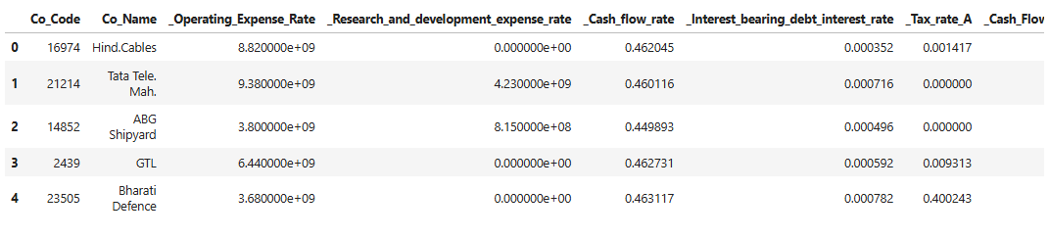
Figure 1: Data head
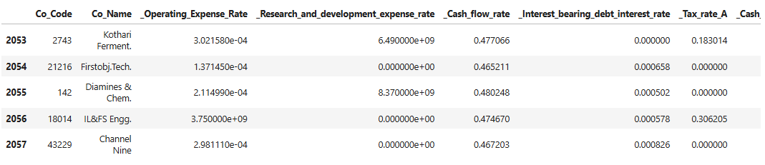
Figure 2: Data Tail
This dataset has 2058 rows and 58 columns

Figure 3: Data Shape

Checking Datatypes of attributes
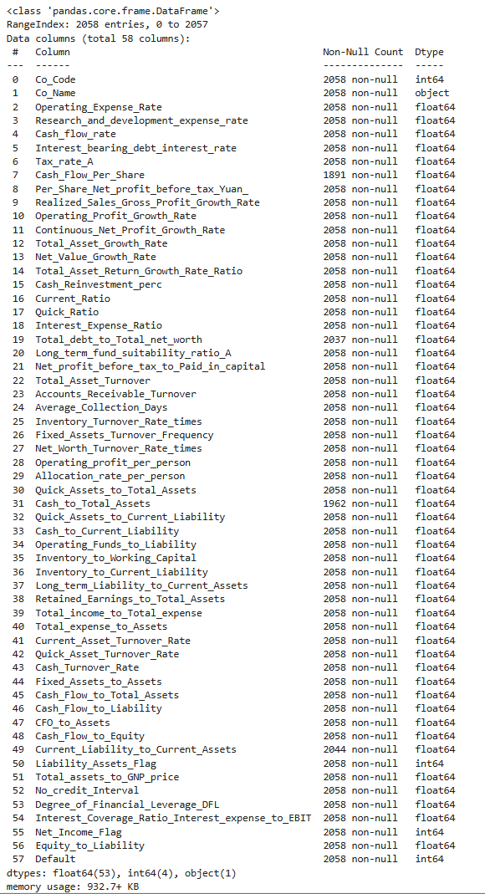
Figure 4: Data Types

Checking for missing values in the data
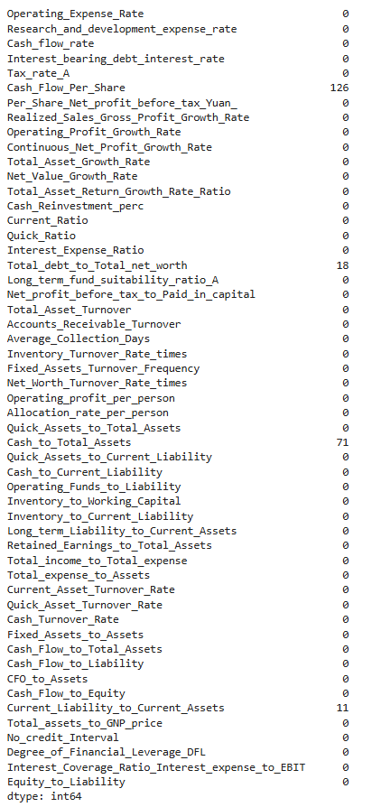
Figure 5: Missing Values in Data
There are missing values in some columns of data will impute those using KNN imputer.

Checking for Duplicate values in Data
Figure 6: No. of Duplicate values
There are no duplicate values in the data.

Checking the Statistical Summary of data
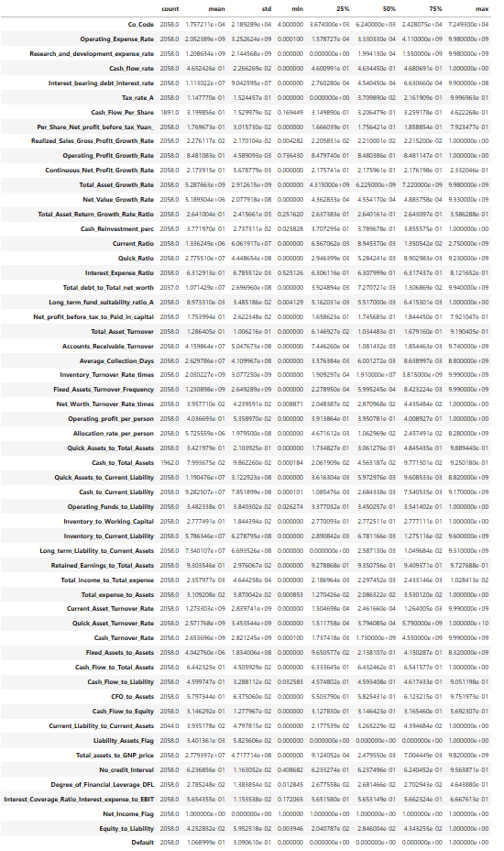
Figure 7: Statistical summary of data

Univariate Analysis
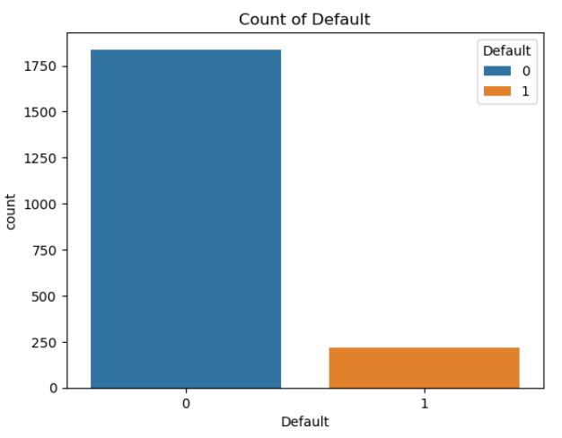
Figure 8: Counts of Target variable
- A large majority of observations (around 1800) fall under Default = 0, meaning no default occurred.
- A much smaller group (around 250) corresponds to Default = 1, indicating defaults
- The dataset is highly imbalanced, with non-defaults significantly outnumbering defaults.
- This imbalance can affect the performance of classification models, especially if accuracy is used as the sole evaluation metric.
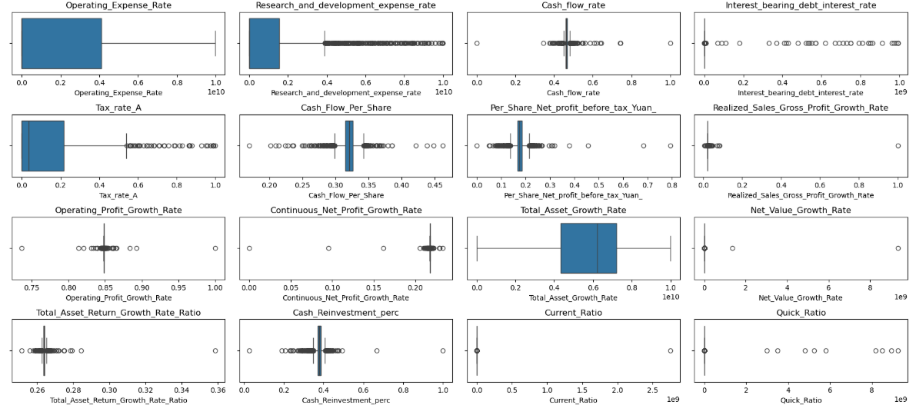
Figure 9: Box plot 1

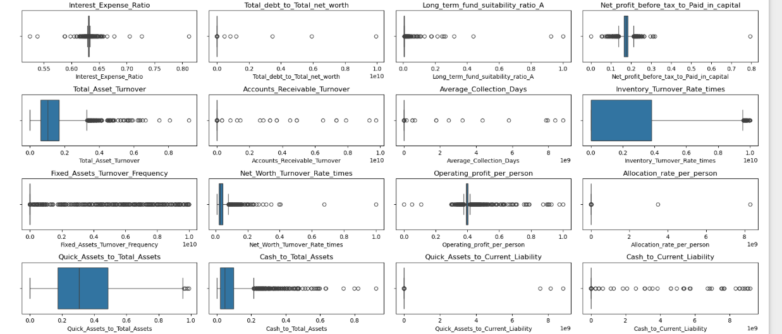
Figure 10: Box plot 2
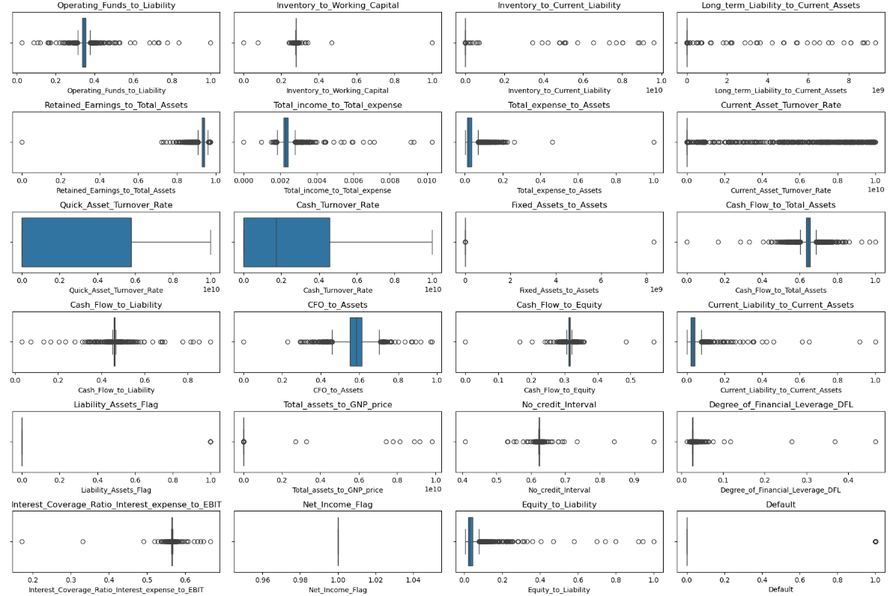
Figure 11: Box plot 3
Observations
- Many financial metrics, such as Cash Flow to Equity, Interest Coverage Ratio, and Inventory to Working Capital, show significant outliers.
- Several variables, including Cash Turnover Rate, Operating Funds to Liability, and CFO to Assets, are right-skewed, indicating that most firms have low values, but a few have exceptionally high ratios.
- Metrics like Net Income Flag, Liability Assets Flag, and Default show minimal variation, with values tightly clustered around 0 or 1.
- Ratios such as Long-Term Liability to Current Assets, Cash Flow to Liability, and Equity to Liability show wide interquartile ranges, indicating substantial variability in financial structure and leverage across firms.
- Metrics like Cash Flow to Total Assets, Interest Coverage Ratio, and Retained Earnings to Total Assets could be strong predictors of default, given their financial relevance and variability.

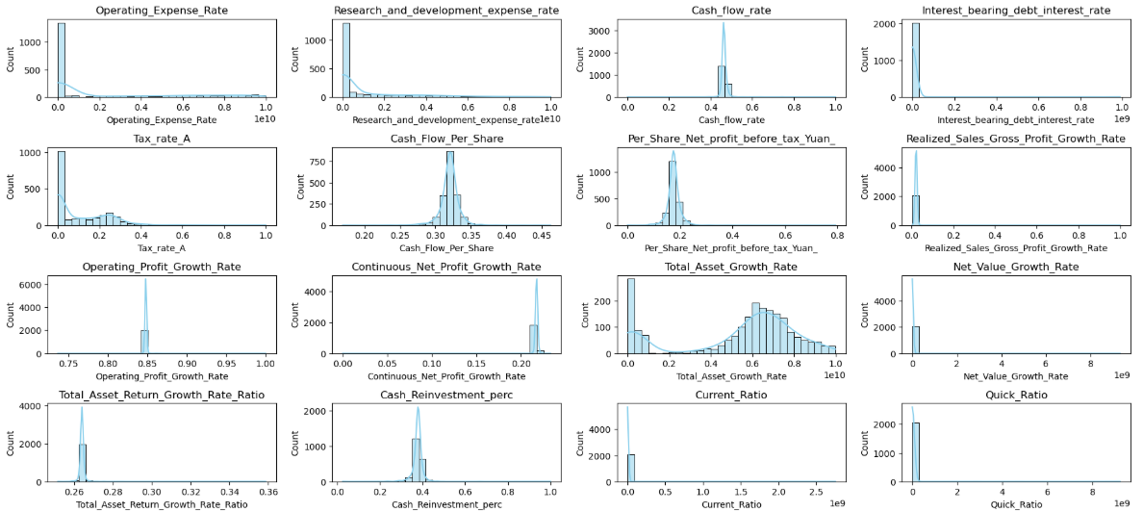
Figure 12: Histogram plot 1

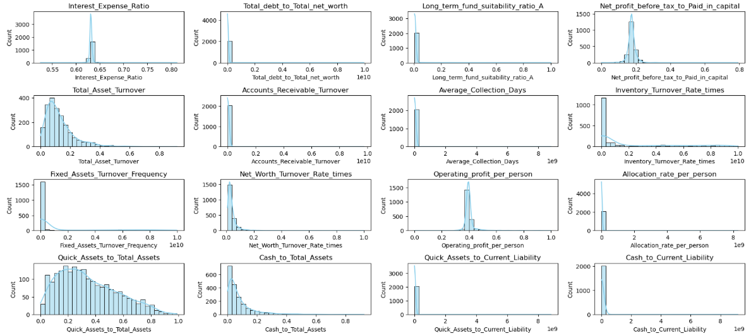
Figure 13: Histogram plot 2

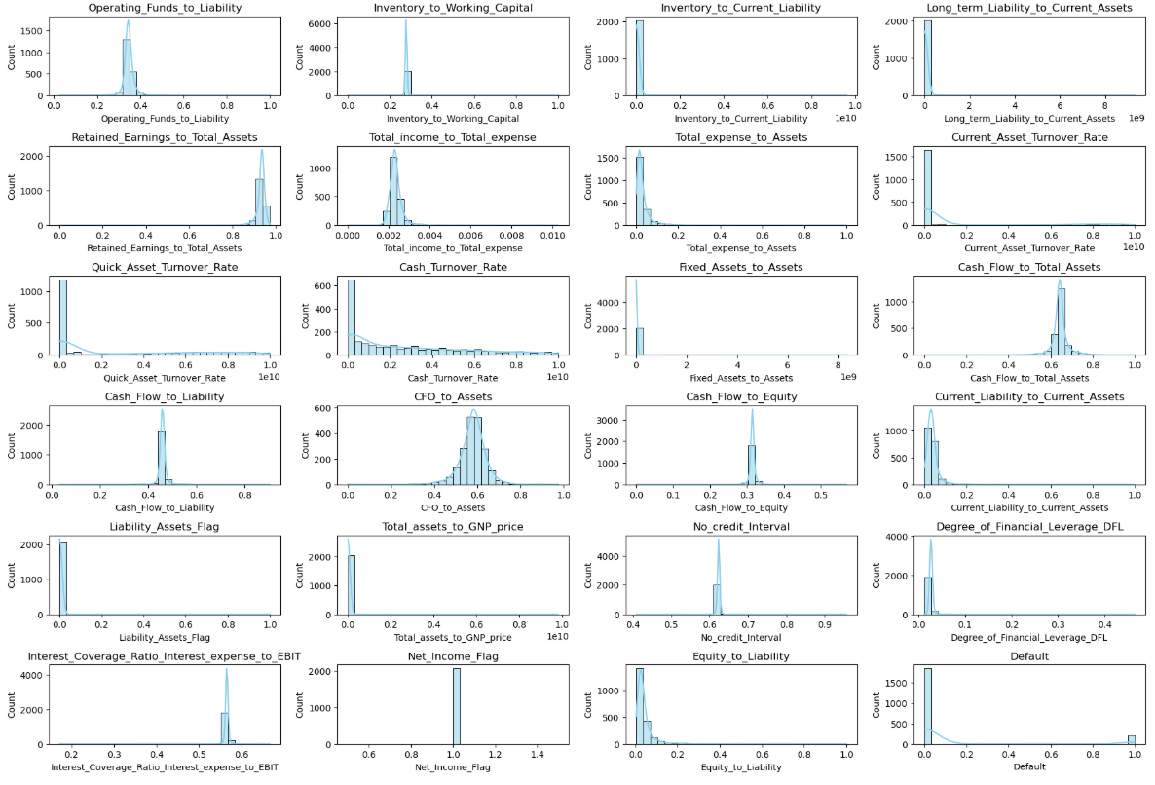
Figure 14: Histogram plot 3

Observations
- Many financial ratios such as Cash Flow to Total Assets, Operating Funds to Liability, and Cash Turnover Rate are right-skewed, meaning most firms have low values, but a few have extremely high ones.
- Variables like Net Income Flag, Liability Assets Flag, and Default show clear binary distributions (0 or 1), confirming their role as categorical indicators.
- Several metrics, including Retained Earnings to Total Assets, Cash Flow to Liability, and CFO to Assets, show a strong concentration near zero.
- Ratios like Long-Term Liability to Current Assets, Equity to Liability, and Interest Coverage Ratio show wide distributions, reflecting diverse capital structures and debt-servicing capacities across firms.
- Metrics such as Current Asset Turnover, Quick Asset Turnover, and Cash Turnover Rate exhibit broad distributions, suggesting significant variation in how efficiently firms utilize their assets

Bivariate Analysis

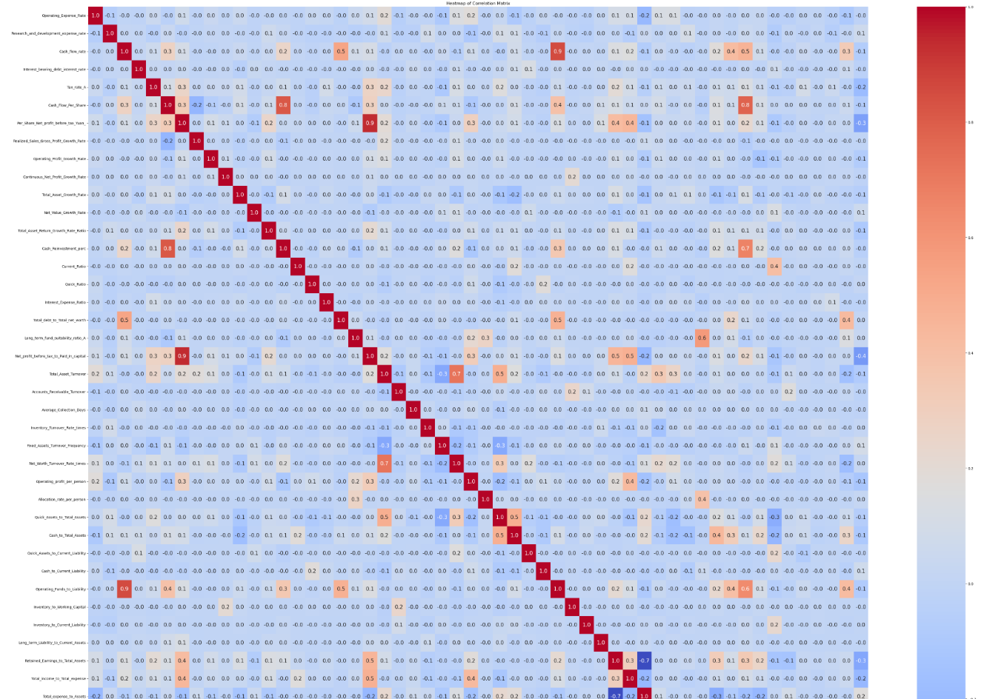
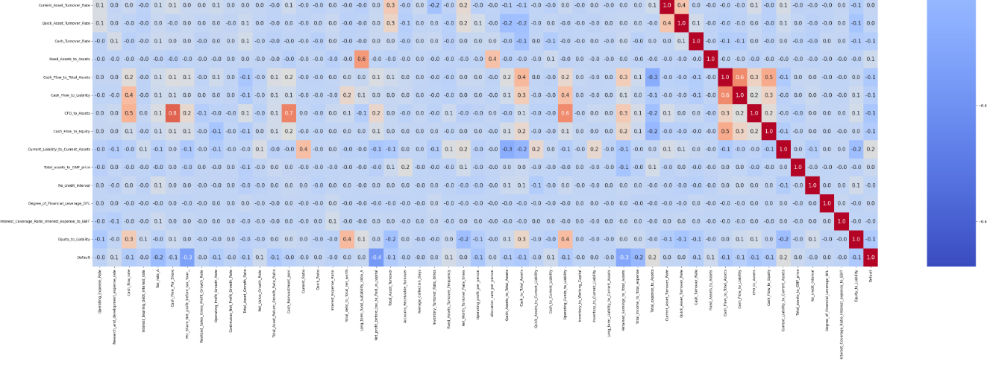
Figure 15: Corelation chart of numerical columns

There are some correlations between variables.

Outliers Check
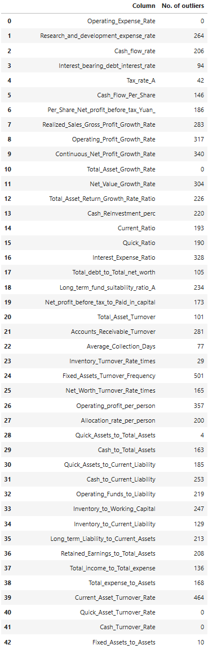
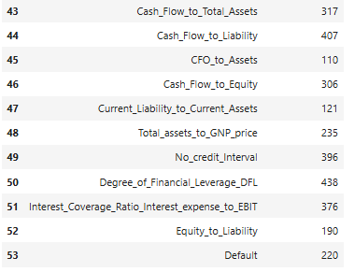
Figure 16: Outliers in data

Data Preparation
Splitting data into Training and Testing data with 75% and 25% accordingly.

Missing values Imputations in Training Data
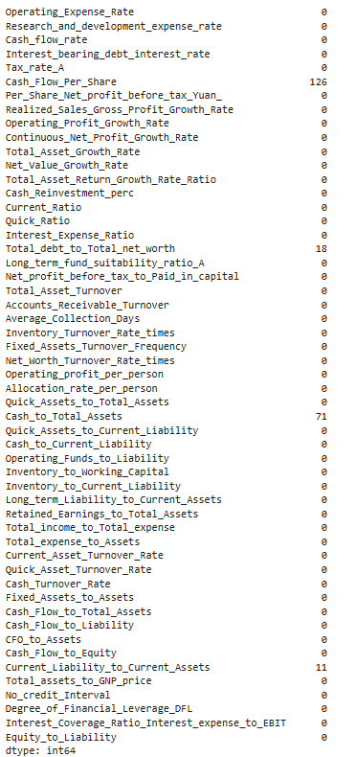
Figure 17: Missing values in training data

Missing values Imputations in Test Data
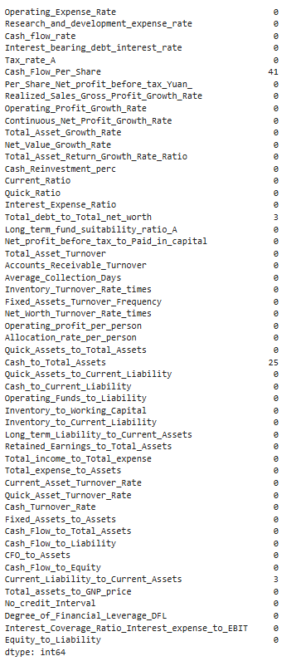
Figure 18: Missing values in test data

Scaling Data
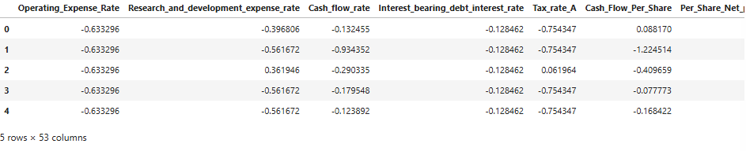
Figure 19: Scaled data Head

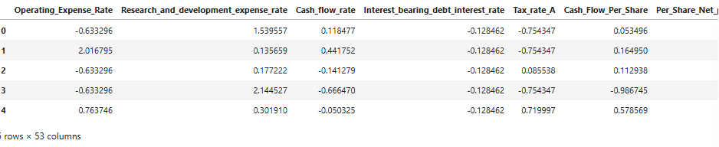
Figure 20: Scaled Data tail

Logistic Regression Model
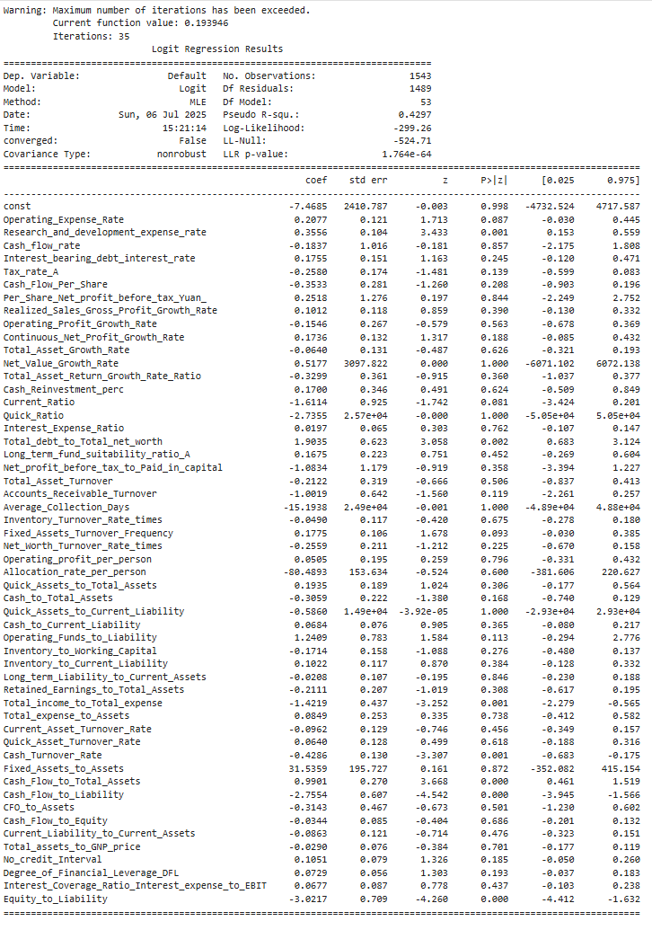
Figure 21: Logistic Regression summary

Logistic Regression Model - Training Performance
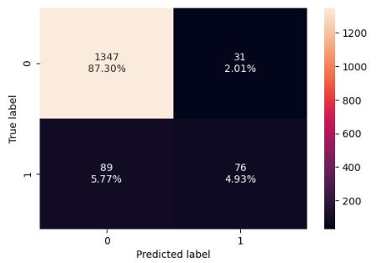
Figure 22: Confusion Matrix of Model
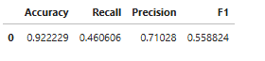
Figure 23: Model Performance

Logistic Regression Model - Test Performance
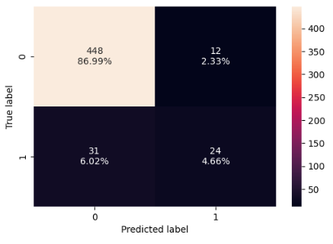
Figure 24: Confusion Matrix of Model
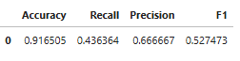
Figure 25: Model Performance

Random Forest Model

Random Forest Model - Training Performance
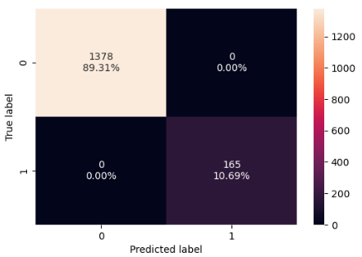
Figure 26: Confusion Matrix of Model
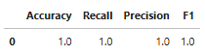
Figure 27: Model Performance

Random Forest Model - Test Performance
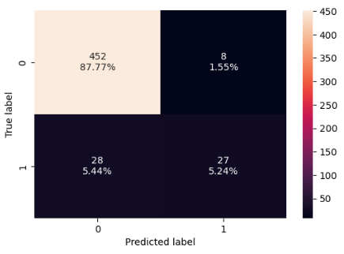
Figure 28: Confusion Matrix of Model

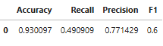
Figure 29: Model Performance

Model Performance Improvement - Logistic Regression
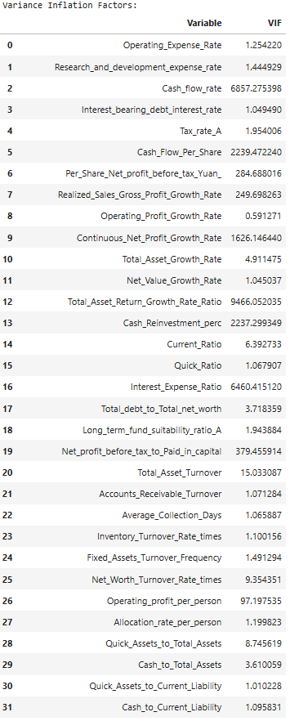
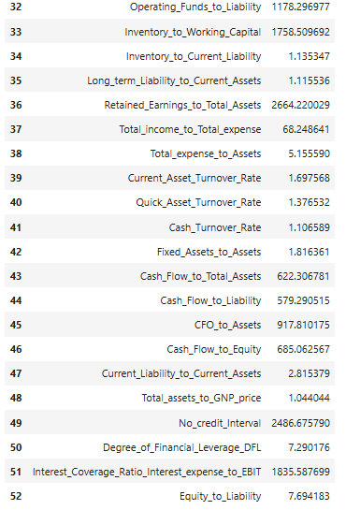
Figure 30: Variance Inflation Factors

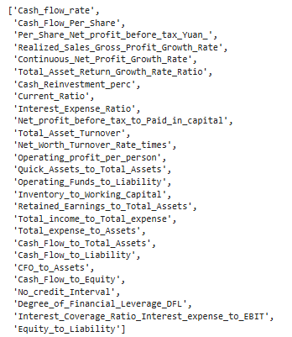
Figure 31: Variables having high VIF
Figure 32: Shape of Training Data
Figure 33: Shape of test Data
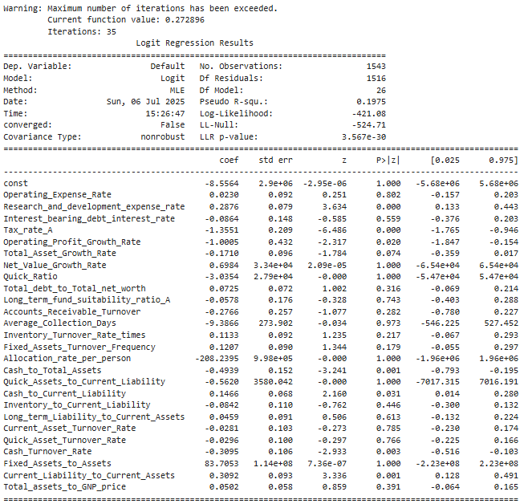
Figure 34: Tuned Logistic Regression Model Summary
Optimal Threshold Value: 0.117
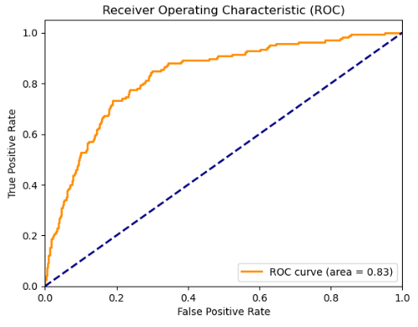
Figure 35: ROC Curve

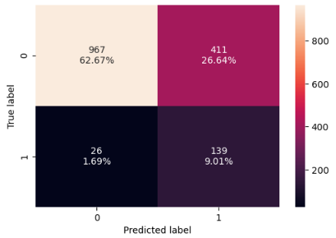
Figure 36: Confusion Matrix of Model
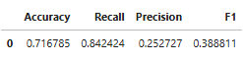
Figure 37: Model Performance
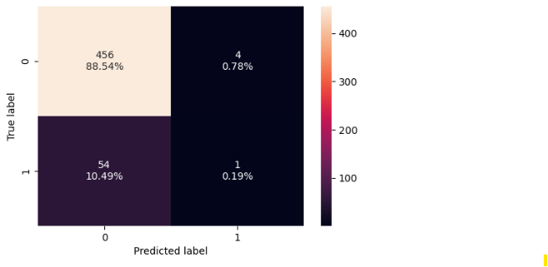
Figure 38: Confusion Matrix of Model
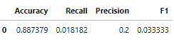
Figure 39: Model Performance

Model Performance Improvement – Random Forest
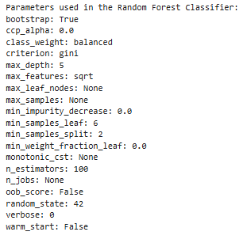
Figure 40: Model Parameters
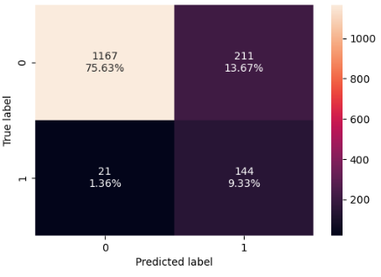
Figure 41: Confusion Matrix of Model
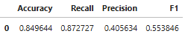
Figure 42: Model Performance
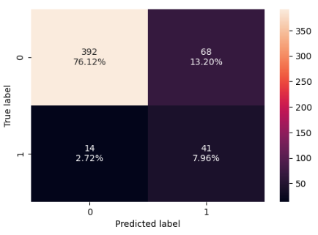
Figure 43: Confusion Matrix of Model
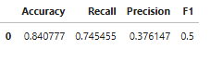
Figure 44: Model Performance

Model Comparison and Final Model Selection
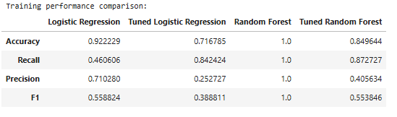
Figure 45: Model Comparison on Training Data
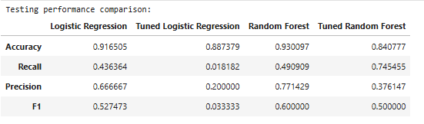
Figure 46: Model Comparison on Test Data
Tuned Random Forest is the best model for this data

Important Features in Final Model
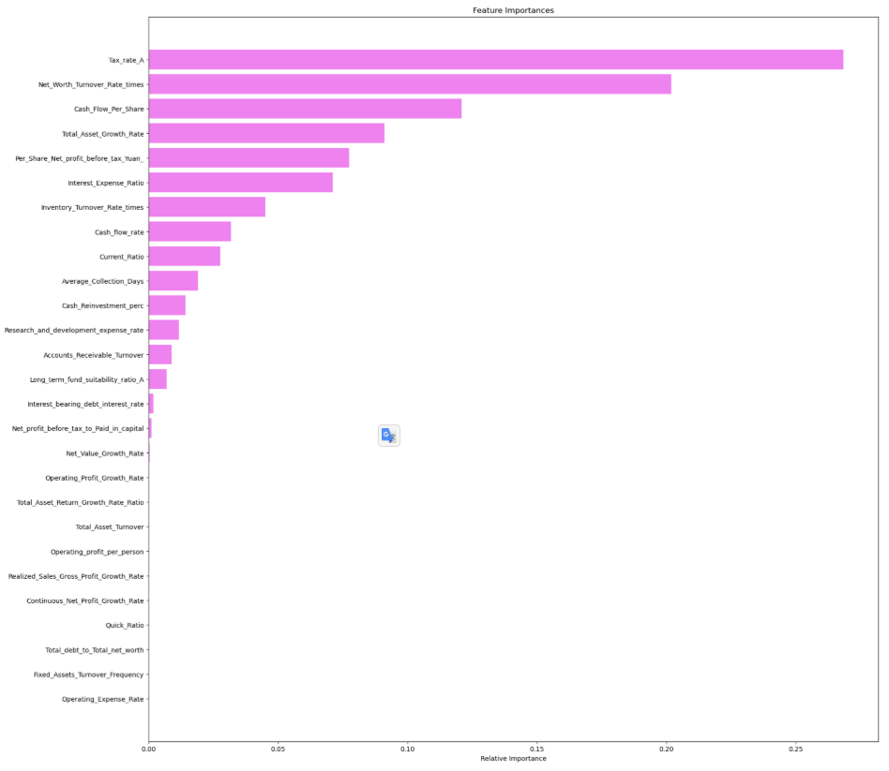
Figure 47: Important Features in Final Model

Insights and Recommendations
Insights
- Cash Flow Strength is a Critical Indicator of Default Risk Companies with low values in features like Cash_Flow_Per_Share and Cash_Flow_to_Liability are significantly more likely to default.
- Tax Rate and Equity Efficiency Reflect Financial Stress A high Tax_rate_A (Effective Tax Rate) and low Net_Worth_Turnover_Rate_times (Equity Turnover) are strong predictors of default.
- Leverage and Solvency Ratios Matter Ratios like Interest_bearing_debt_interest_rate and Total_debt_to_Total_net_worth are consistently higher in defaulting companies.
- Growth Metrics Alone Are Not Sufficient Features like Total_Asset_Growth_Rate or Operating_Profit_Growth_Rate were not among the top predictors.

Recommendations
- Prioritize Cash Flow Metrics in Credit Evaluation Incorporate cash flow–based ratios as primary indicators in the Financial Health Assessment Tool.
- Develop a Risk Scoring System Based on Top Predictors Build a transparent scoring model that weights features like Tax_rate_A, Cash_Flow_Per_Share, and Net_Worth_Turnover_Rate_times.
- Enable Dynamic Threshold Adjustment for Risk Appetite Allow users (e.g., investors or analysts) to adjust the classification threshold to balance recall and precision based on their tolerance for false positives.
- Monitor Leverage and Solvency Trends Over Time Integrate trend analysis for key ratios like Debt-to-Equity and Interest Coverage to detect deteriorating financial health early.
- Educate Clients on Interpreting Financial Red Flags Provide guidance within the tool to help users understand why a company is flagged.
- Retrain and Validate the Model Periodically Financial patterns evolve with market conditions. Regularly update the model with new fiscal data to maintain predictive accuracy and relevance.

